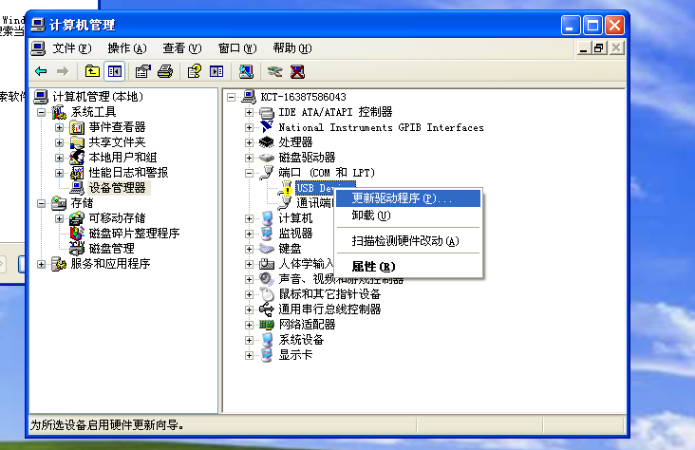
点击USB 鼠标右键更新驱动程序进入下一个界面

Click Right button of mouse on “my computer” to open the device manager as above,turn off the watch, then connect the cable to the turn-off status watch, sometimes it will prompt “install USB driver”, sometimes it prompts “unknow device” in the device manager. If it is a yellow exclamation mark, click right key of mouse and go to renew driver as above.

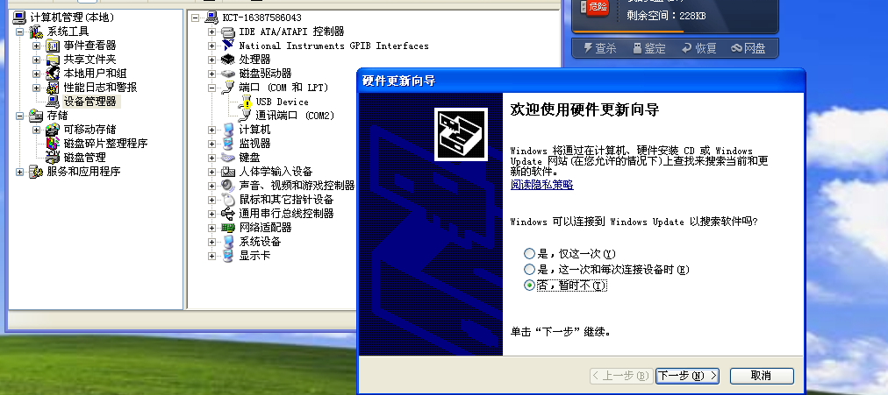

Click next step
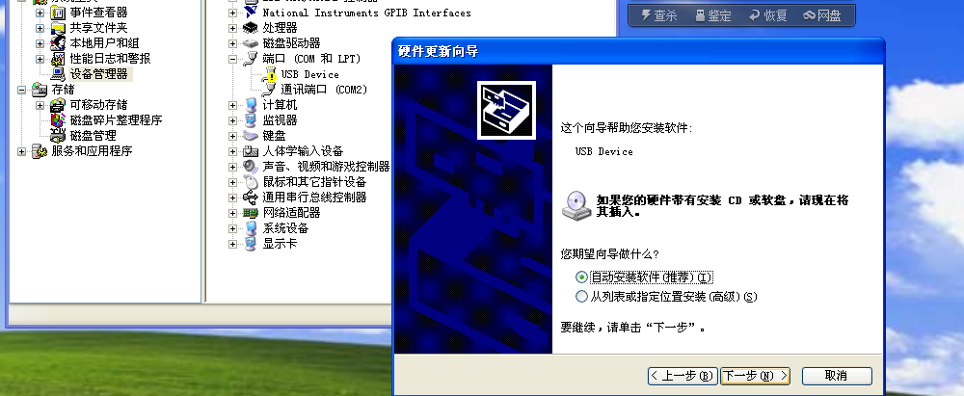

Select the location of driver

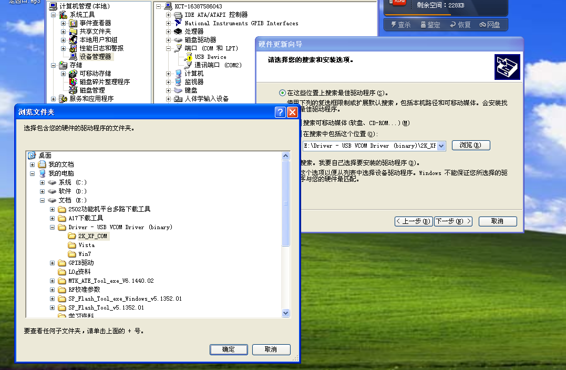
Click the “browse” button, select the location where the driver is, select win7 fold if on windows 7 or select “2KXP COM ” on windows xp
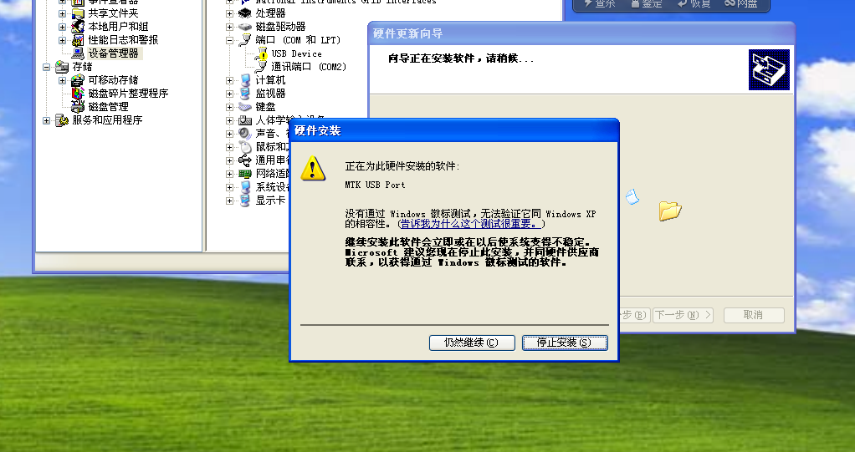

Keep going on

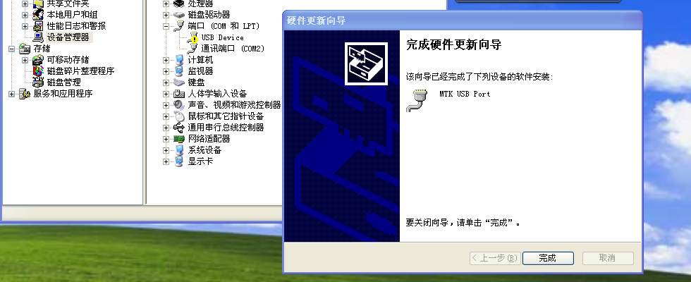

Finish the driver installation, need to do it again if change to another computer

